5.5 Planning Proposal - North Orange Shopping Centre Expansion

TRIM REFERENCE: 2016/1819

AUTHOR: Craig Mortell, Senior Planner

**EXECUTIVE Summary**

Council is in receipt of a planning proposal from City Plan Services, on behalf of SCA Property Group, relating to Lot 700 DP 1171441, known as 9 Telopea Way.

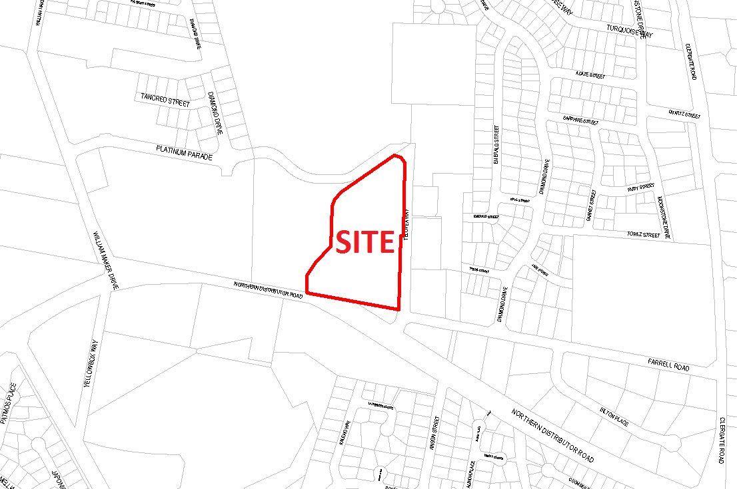

Currently, the southern portion of 9 Telopea Way is zoned B2 Local Centre and has already been developed as the North Orange shopping centre, comprising a Woolworths supermarket, several specialty shops and the associated car parking area.

The proposal relates to the northern residual portion of the lot which is zoned R1 General Residential and is currently vacant. The proposal seeks to convert the northern area to the B2 Local Centre zone to enable an expansion of the existing shopping centre. The proposal originally sought to enable:

* A new supermarket of 4,000m2 area
* Expansion of the current supermarket from 3,200m2 to 4,000m2
* A future mini-supermarket of 1,500m2, and
* Creation of additional 1,400m2 specialty retail area (estimated as 14 – 18 outlets)

When added to the current supermarket and 1,644m2 of specialty retail this proposal would take the site to a total of 12,544m2 of retail floor space. The North Orange shopping centre was originally established following adoption of the Council’s Business Centre Review (BCR) Strategy.

The Strategy was prepared for Council by Leyshon Consulting and they are a long established consulting firm providing economic analysis and advice to a wide range of NSW councils and other clients around Australia. Instrumental in the original Business Centre Review and all subsequent updates Director Peter Leyshon has a thorough and detailed understanding of the Orange commercial hierarchy, catchment or trading areas and the dynamics that contribute to Orange being a key regional trading centre.

The BCR sought to define the role and scale of the out-of-CBD centre to balance the needs of North Orange residents with the broader benefit of maintaining the regional significance of the Orange CBD.

Following extensive negotiation with the proponent and Council’s consultant, Peter Leyshon, the planning proposal has been revised to now provide the following:

* Expansion of the current supermarket from 3,200m2 to 4,000m2
* Creation of a mini-supermarket of 1,750m2, and
* Additional specialty retail area of 800m2 (estimated as 8 – 10 outlets).

The change in mini-supermarket size follows further consultation with a prospective tenant to confirm their operational requirements. The reduction in specialty retail area helps to ensure the subordinate role of the North Orange centre is maintained. It must be noted that this rezoning proposal is not designed to allow a Discount Department store and a commitment has been gained from the applicant in this regard. Staff will work with the Department on how this can be ensured in the final amendment wording.

Given the location this report also has regard for the future role of land on the other side of Telopea Way, known as Lot 111 DP 1194964, which was the subject of a previous planning proposal from Garfield Road Holdings Pty Limited (GRH) for a service station and restaurant that was rejected due to traffic congestion and interface with residential development.

**Link To Delivery/OPerational Plan**

The recommendation in this report relates to the Delivery/Operational Plan strategy “1.2 Our City - Information and advice provided for the decision-making process will be succinct, reasoned, accurate, timely and balanced”.

**Financial Implications**

Council has been advised that as a council included in the NSW Government’s merger proposals under consideration by the Office of Local Government since referral on 6 January 2016, Council must comply with the merger proposal period guidelines issued under S23A of the Local Government Act 1993.

The guidelines instruct Council it should expend money in accordance with the detailed budget adopted for the purposes of implementing the Delivery/Operational Plan for the 2015/16 year.

Any expenditure outside the adopted budget requires the identification of clear and compelling grounds and must be approved by Council at a meeting that is open to the public. The guidelines indicate the resolution of Council for increased expenditure must specify the reasons why the expenditure is required and warranted.

If increased expenditure is greater than $250,000 or 1% of the Council’s revenue from rates in the preceding year, whichever is the greater, Council is required to exhibit the increase to the budget and consider comments received.

Council must also avoid entering into contracts or undertakings where expenditure or revenue is greater than $250,000 or 1% of the Council’s revenue from rates in the preceding year, whichever is the greater, unless the contract or undertaking is as a result of a decision or procurement process commenced prior to the merger proposal period or where entering into a contract or undertaking is reasonably necessary for the purposes of meeting the ongoing service delivery commitments of the Council or was previously approved in the Council’s Delivery/Operational Plan.

**Policy and Governance Implications**

Nil

*Do not delete this line*

|  |
| --- |
| **Recommendation**  **1 That Council support a Planning Proposal at 9 Telopea Way to:**  **a) rezone the northern portion of Lot 700 DP 1171441 to B2 Local Centre**  **b) amend the Floor Space Ratio map to apply a rate of 0.2:1 across the site, enabling a total of 3,100m2 of additional lettable floor space**  **2 That Council seeks a Gateway Determination from the Department of Planning and Environment consistent with the above and then undertake public exhibition for a period of 28 days prior to reporting back to Council.**  **3 That Council’s support is predicated on the centre not allowing higher order retail uses such as Discount Department Stores and that absent resolution of this condition that support be withdrawn.** |

*Do not delete this line*

**further considerations**

The recommendation of this report has been assessed against Council’s other key risk categories and the following comments are provided:

|  |  |
| --- | --- |
| Environmental | The expansion of an out of centre commercial precinct needs to be balanced against the objective of maintaining a strong and robust central business district. Additionally, the site is accessed through an intersection that has already been the subject of significant community concern. Accordingly, traffic mitigation strategies need to be considered for any additional development in this location. These issues are discussed in the body of the report. |

**SUPPORTING INFORMATION**

While the North Orange shopping centre was originally developed by Woolworths and the current proposal involves a potential expansion of the Woolworths supermarket, it should be noted that Woolworths no longer hold an interest in the site, beyond being tenants of the centre.

The proponent is SCA Property Group, established by Woolworths to be a landlord for a number of its owned shopping centres in October 2012. Woolworths transferred ownership of the shopping centres to SCA and then transferred SCA to Woolworths shareholders (an in-specie distribution).

SCA is listed on the ASX and according to the SCA Property Group website *“Woolworths has no ownership interest in SCA Property Group following its listing”.*

SCA Property Group, as landowner of 9 Telopea Way, are seeking to expand the North Orange shopping centre to enable a second full line supermarket, several additional specialty shops and a potential mini-supermarket.

A conceptual site plan has been included in the proposal to illustrate how such an expansion could be designed. However, the ultimate design of any expansion would be the subject of a future development application, which could involve various changes to the concept presented. The value of the conceptual plan is therefore to illustrate the overall scale of the expansion and affirm that a workable design is possible on the site (subject to rezoning).

SCA contend that expansion of the centre is justified on the basis of a growing population base in North Orange. The proposal includes an economic impact assessment and a traffic report by the proponent to seek to address the most significant issues relating to the site and locality.

This report also has regard for the future role of land on the eastern side of Telopea Way, known as Lot 111 DP 1194964, which was the subject of a previous planning proposal from Garfield Road Holdings Pty Limited (GRH) for a service station and restaurant rezoning.

Council rejected that proposal and GRH subsequently sought to have Council’s decision overturned by the Joint Regional Planning Panel (JRPP). After a lengthy process the JRPP ultimately upheld Council’s rejection of the GRH proposal.

SCA and GRH are unrelated entities and each proposal needs to be considered on its individual merits. However the cumulative effects of each proposal are influenced by the other and therefore become relevant considerations. It is in this context that the GRH proposal is discussed.

**Location context**

Telopea Way is a short north-south cul-de-sac connecting at its southern end with the Northern Distributor Road (NDR). A short distance north of this intersection is an eastern connection to Farrell Road providing a link through to the surrounding residential area. The proximity of development in the area has resulted in significant traffic volumes. Additionally, some motorists have reported the configuration of the two intersections and the associated lights to be difficult.

The existing North Orange shopping centre comprises a 3,200m2 Woolworths supermarket with a further 1,644m2 of specialty shops, including a liquor outlet. The total floor space is consistent with the floor space ratio map established to reflect the recommendations of the Council’s Business Centres Review Strategy. A key focus of the strategy was to establish an appropriate scale for the centre, balancing the needs of the local population in North Orange against preserving the trading performance and role of the Orange CBD. The potential for further expansion of the centre was noted in the strategy predicated upon the population base growing as supply of residential zone land in North Orange was taken up.

Subsequently, approval has been granted for a McDonald’s outlet at the corner of Telopea Way, Farrell Road and the NDR. A Planning Proposal for a restaurant and petrol station on land directly opposite this site was rejected by Council on a range of factors; principally compatibility with adjoining residential land to the east, proximity to established and approved child care centres, and traffic at the Telopea Way, Farrell Road and NDR intersections. The proponent Garfield Road Holdings Pty Limited (GRH) subsequently sought to have Councils decision overturned by the State government by applying to the Department of Planning via the Western Region JRPP to have their proposal for a rezoning re-examined.

Despite Council staff representations, the JRPP determined that the matter could proceed to the gateway process. The Department of Planning and Environment then acted as the relevant planning authority for processing of the proposal. After lengthy consideration the proposal was ultimately rejected for a variety of reasons, not least being a nearby alternative site for such development already exists at Hanrahan Place.

The subject land is on the western side of Telopea Way and differs to the rejected site on the eastern side of Telopea Way by virtue of being separated from the residential properties and child care centre. In addition, Council will soon commence construction of a road connection to the west that would link the northern end of Telopea Way to the recently constructed western section of Diamond Drive. This connection will provide a valuable relief route to ease congestion at the NDR/Farrell Rd intersection.

Given the above history of development on and around Telopea Way and the continued growth of North Orange, there is considered to be scope for some level of expansion. Community concern relating to traffic in this area is considerable.

An out of centre shopping precinct in North Orange was found to be appropriate in the Business Centre Review Strategy. The Strategy identified the appropriate scale for the centre, both in terms of meeting the needs of local residents and also protecting the overall trading performance of the CBD. The current proposal has been reviewed by the consultant who prepared the Business Centre Review Strategy, Peter Leyshon to ascertain how, given the passage of time and population growth, it would relate to the overall Orange economy and CBD impacts.

Leyshon’s review of the SCA economic case is attached to this report. The main findings can be summarised as not supporting the extent of floor space originally sought in the short term, but recognising that there may be a case for a more modest expansion. The full proposal of two full line supermarkets and a mini-supermarket would not be justifiable until 2028. With regard to the revised proposal of one full line supermarket, one mini-supermarket and 800m2 specialty shops Leyshon states:

*“the proposed expansion of the North Orange centre is considered to be reasonable from my perspective. The proposed addition of specialty retail floorspace (800 m2) will result in 8 – 10 businesses being added to the centre. Not all of these businesses will be retail in nature, however. I do not consider that the proposed addition of the specialty retail will alter the role of the North Orange centre or pose an undue threat to the Orange CBD. The proposed expansion of Woolworths, and the addition of Aldi, are considered to be consistent with the demand estimates for supermarket floorspace in the trade area of the North Orange centre.”*

**CBD implications**

Since the opening of the North Orange shopping centre, the occupancy rate of commercial premises in the CBD has not appreciably changed. The level of vacant premises pre and post North Orange opening is anecdotally consistent. This does not mean that trading performance or profitability of CBD businesses has been unaffected.

Doubtless some have seen a portion of their trade lost, however such effects are difficult to distinguish from other causal factors such as the transition of the Cadia East mine from construction to operational phases, and more general or macro-economic conditions. While the full effect on the CBD is not certain, the precautionary principle would suggest that a more modest expansion, or a staging over time of the expansion, be contemplated.

The significance and role of the CBD as the primary trading centre in the central west should not be taken for granted. Should the CBD performance decline or even just stagnate there is potential for the outer edges of the catchment (e.g. Blayney, Molong, Canowindra and the like) to begin to look towards other regional centres for their higher order shopping.

The eastern edges of the catchment may turn more towards Bathurst, with the north-western edges potentially looking towards Dubbo, albeit at a greater distance. It is likely that any such changes in shopping patterns would initially be small and difficult to measure. However, settlement patterns in Australia since the 1960s have been known to exhibit a very high level of “primacy” compared to other developed nations.

In this context, primacy refers to the tendency for population, trade and development to concentrate in one location or city where all higher order activities for the region occur, and for surrounding population centres to be diminished in scale, providing only lower order goods and services. Primacy occurs around the developed world, but is particularly pronounced in Australia.

In our local context the Orange-Bathurst combination stands out as an exception to the primacy norm in that while being in close proximity, neither centre has significantly outshone the other. This should not be interpreted to mean that the primacy effect does not apply to Orange simply that both centres have managed to keep pace with each other.

Accordingly, Council needs to balance the short term desire to provide enhanced facilities for residents of North Orange with the long term strategic interest of preserving and enhancing the trading performance and role of the CBD.

Subsequent to the lodging of the planning proposal in September 2014, staff have been involved in protracted negotiations with SCA over the extent and timing of any expansion to the North Orange shopping centre. The focus of discussions has been to balance the legitimate expansion of facilities in North Orange with preserving the role and function of the CBD.

Council has also been approached by Aldi seeking a suitable location for a second store in Orange, with a strong preference for North Orange. Due to the relevance and timeliness of this interest analysis supplied by Aldi of the Orange supermarket sector has also been considered, alongside the SCA analysis and Leyshon’s advice, in relation to this proposal.

Aldi note that there are currently 7 supermarkets in Orange ranging from 665m2 Foodworks in Dalton Street to 3,713m2 Coles in Orange Central for a total of 16,227m2 of supermarket floorspace. With a population estimate of 43,624 this equates to a ratio of 0.37m2 per capita.

A comparison is then provided against 14 other regional and coastal centres of comparable population showing supermarket floorspace ratio’s of 0.38m2 up to 0.68m2 per capita (averaging 0.47m2 per capita). While this potentially portrays Orange as being underserved in the supermarket sector it must be remembered that the analysis was prepared to justify adding to the current supply.

**Current supermarket sector in Orange**

|  |  |  |
| --- | --- | --- |
| **Location** | **Operator** | **Size** |
| CBD | Woolworths | 3,330m2 |
| CBD | Coles | 3,713m2 |
| CBD | IGA (Peisley st) | 2,207m2 |
| CBD | IGA (Summer centre) | 1,650m2 |
| CBD | Aldi | 1,462m2 |
| North Orange | Woolworths | 3,200m2 |
| Alpine Stores | Foodworks* | 665m2 |
| Total | | 16,227m2 |

* It should be noted that the Foodworks store recently applied to expand their operation into an adjoining tenancy.

**Comparable regional / coastal centres**

|  |  |  |
| --- | --- | --- |
| City | Estimated Resident Population (June 2015 – significant urban area ABS) | Supermarket floorspace ratio (Aldi estimate) |
| Grafton | 18,689 | 0.68m2 |
| Batemans Bay | 16,680 | 0.64m2 |
| Coffs Harbour | 68,572 | 0.60m2 |
| Bowral-Mittagong | 37,897 | 0.55m2 |
| Taree | 26,390 | 0.50m2 |
| Dubbo | 36,941 | 0.47m2 |
| Tamworth | 42,255 | 0.46m2 |
| Lismore | 29,413 | 0.44m2 |
| Nowra | 35,920 | 0.44m2 |
| Port Macquarie | 45,341 | 0.43m2 |
| Armidale | 23,674 | 0.43m2 |
| Bathurst | 36,013 | 0.41m2 |
| Wagga Wagga | 55,820 | 0.40m2 |
| Cessnock | 22,596 | 0.39m2 |
| **Orange** | **40,075** | **0.37m2** |

Note: the floor space ratio estimate is related to a population catchment that has a 15km radius which in most cases extends beyond the significant urban area for the population figure.

Each analysis agrees that a contemporary full line supermarket is 4,000m2 of floor space would require a catchment population of 8,000 – 10,000 to be viable. In this regard the 7 current supermarkets have a floor space equivalent of 4.05 full line supermarkets. The current population of Orange at 40,000 could therefore support 5 full line supermarkets.

**Population projections**

The regional catchment of Orange generally corresponds to the local government areas of Orange, Cabonne and Blayney – although for some higher level services it would draw on a wider area. The current 2016 population estimate is 65,550 people of which two-thirds or 42,200 people live in Orange. Following a more stagnant period from 2001 – 2006 growth has been relatively strong. Solid growth is projected to continue over the short to medium term out to 2031 as shown in the chart below.

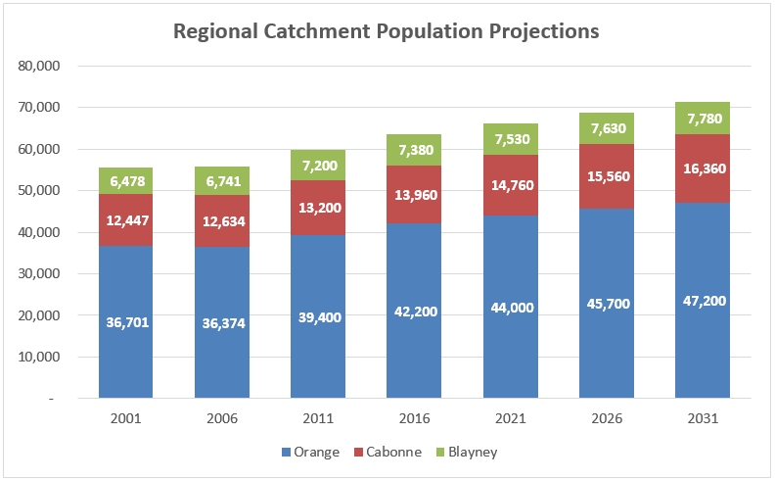

**Source – Aldi analysis prepared by Deep End Services**

This will increase the capacity of Orange to support additional supermarket floor space. Any impacts upon the CBD are therefore likely to be temporary, particularly as urban growth switches from North Orange to southern areas such as Shiralee as southern residents are more likely to shop in the CBD due to proximity, until such time as a southern shopping centre emerges in response to population growth.

In the longer term CBD dominance would rely upon a combination of balancing urban growth geographically so that the CBD remains central to all, carefully increasing residential density of “inner” Orange, and providing higher order goods and services to draw trade from across the region.

**Traffic Implications**

The proponent supplied a traffic review in support of the proposal. It should be noted that their review was prepared on the basis of the additional supermarket floor space (total 4,800m2) and the additional specialty retail area (1,500m2), but excluded the “future retail” area of 1,400m2. The traffic review also limited its calculations to the short to midterm horizon, despite acknowledging that the long term demand would be higher. Finally, the traffic review notes that Council has identified an east-west link road between the northern end of Telopea Way and William Maker Drive as part of the preferred solution to the local traffic concerns. Additional elements of the traffic solution potentially include a slip lane into Farrell Road from Telopea Way, this requires further investigation.

The intent of the relief link is to provide a relief route for local traffic so that residents to the north and west will be able to avoid the NDR intersection. Accordingly, should the proposal be supported SCA would be required to contribute a reasonable apportionment of costs for the traffic solution including the relief link road and slip lane. In addition a precinct-wide traffic analysis has been undertaken for this area, from Hill St to Farrell Rd/Telopea Way and Clergate Rd along the NDR to assess the overall traffic impacts on the area of additional residential and commercial development in the future. This assessment will identify a range of intersection improvement works which will be required over time, and a process developed for apportioning contributions from individual developments to cover the cost of these upgrades. The financial contribution required would become the subject of a Voluntary Planning Agreement between Council and the developer. The proponent (SCA) has been advised of this work and have acknowledged that their proposal would add to the need for the roadworks involved.

In the long term, when the area is fully developed the proposal is anticipated to generate an additional 800 vehicles per hour (two-way) in the weekday afternoon peak hour. Assuming an even distribution during the peak period, this equates to an additional movement every 4.5 seconds. In the short to medium term the proponent argues that traffic generation during the peak hour would be in the order of 450 vehicles per hour (two-way), or an additional movement every 8 seconds, assuming even distribution during the peak.

**Planning controls**

Land Use Zone

The proposal seeks to change the zone applied to the northern portion of the site from R1 General Residential to B2 Local Centre, consistent with the remainder of the shopping centre site to the south.

The adjoining land to the north and west is zoned RE1 Public Recreation, while land to the east comprises R1 General Residential land on the other side of Telopea Way.

It is considered that the proposal does not raise any particular interface issues or land use conflicts with the surrounding lands. The neighbouring residential land is separated by the Telopea Way reserve, which serves to provide a modest buffer; whereas the northern and western neighbouring lands, being recreation lands, are not considered to be sensitive receptors. Interface issues can therefore be appropriately managed through the usual development application processes.

Floor Space Ratio Controls

The existing shopping centre is subject to a floor space ratio control.

This was imposed to ensure that the scale of the centre would be consistent with the Urban Centres Review Strategy. The proponents originally sought an FSR of 0.321:1 over the site, which is a significant increase over the current 0.19:1 affecting the existing B2 zoned land.

Leyshon’s review of the economic argument indicates that providing 3,350m2 of floor space for the expansion of the existing Woolworths, addition of Aldi and additional specialty shops, but not supporting the further 4,000m2 needed for the additional full line supermarket, may represent an appropriate level of expansion at this time.

This translates to a total floor space of 8,194m2 (existing centre 4,844m2 + proposed expansion 3350m2).

With the expansion of the B2 zone over the remainder of Lot 700 DP 1171441 the total site area becomes 39,055m2. An FSR of 0.21:1 for the entirety of the site would enable 8,201m2 of lettable floorspace.

**Planning proposal process**

Should Council decide to proceed with the proposal, either as requested by the proponent or as modified in accordance with the details above, the processes involved are summarised as follows:

* Prepare draft LEP maps for the zoning and floor space ratio changes.
* Submit the above to the Department of Planning and Environment for the Gateway Review.
* Upon receipt of the Gateway Determination, undertake such studies or further works as may be required.
* Commence the formal consultation phase as required by the Gateway Determination. This will most likely involve consultation with Government departments and agencies, as well as a minimum 28 day public exhibition phase.
* Analyse and report back to Council on the results of consultation and public exhibition. This may involve changes to the concept to accommodate the concerns raised during exhibition and consultation.
* Upon Council adoption, submit the final proposal to Parliamentary Counsel via the Department of Planning and Environment, requesting a formal opinion and gazettal of the LEP component of the plan. The master plan component would be incorporated into the Orange Development Control Plan at the same time.

**Conclusion**

Examination of a request for a Planning Proposal and review of the economic case provided has indicated that the continued growth of North Orange may now justify a moderate expansion of the current shopping centre. The site is directly across the road from a previous request that was rejected by Council over concerns relating to the proximity of child care centres, adjoining residential properties and traffic issues.

This proposal is situated on the western side of Telopea Way, providing a more definitive separation buffer to the more sensitive land uses in the east, and staff are investigating potential relief routes to connect the northern end of Telopea Way with Diamond Drive to the west.

The current proposal is seen to have some merit, albeit that a peer review of the economic case has indicated that a more modest expansion than originally requested is likely to meet the short to medium term needs of North Orange residents without unduly impacting upon the trading performance and role of the main CBD.

Accordingly, it is recommended to proceed with a modified version of the planning proposal at this stage. The additional full line 4,000m2 supermarket (when combined with the rest of the proposal) is considered premature. The best estimate available from Council’s consultant is that by 2028 the population catchment may have grown sufficiently to allow a further expansion without undue consequence to the CBD.

*Do not delete this line*

**Attachments**

1 Draft Planning Proposal, D15/4505

2 Proponents' Planning Proposal North Orange, D15/4507

3 Appendix 1 Letter from Orange City Council, D15/4509

4 Appendix 2 Indicative Concept Layout, D15/4511

5 Appendix 3 Economic Impact Assessment, D15/4513

6 Appendix 4 Traffic Review Report, D15/4515

7 Appendix 5 Deposited Plan, D15/4517

8 Leyshon Consulting North Orange Advice, D15/4519

9 Potential Link Road Corridor, D15/4891